Name: Devangbhai Pandit
Std No: 041145889
Assignment 02 – Build a GUI App
Date: 13th March 2026
Prof Name: Marwan Farah

Table of Contents

Introduction 3
MVC Architecture 3
Layout Design 4
User Interface Controls 5
Event Handling and Listeners 6
ObservableList and TableView Data 7
Validation 7
Challenges 8
Conclusion 8

Introduction
The purpose of this project was to create a GUI app by using JavaFX while applying Model-View-Controller (MVC) Architecture. The application created is Health Appointment Manager which allows user to manage patient medical appointments.
The program is supported with Create, Read, Update and Delete (CRUD) Operations for the appointment records. Each records contains the information like:
- PatientID
- PatientName
- Appointment Date
- Appointment Time
- Doctor Name
- Reason to Visit
The GUI was designed using FXML in Scene Builder and the application logic was implemented using Java controllers in IntelliJ IDEA IDE. The interface includes the menu, buttons and table-based view to display and manage the health appointments.

MVC Architecture
The application follows the MVC Architecture pattern, which divides it into three components:
Model
The model represents the application's data and business logic. In this project, the model is implemented in the Appointment.java file
This class represents a single health appointment. It stores information such as patient ID, patient name, appointment date, appointment time, doctor, and condition.
JavaFX Property classes such as StringProperty and ObjectProperty were used instead of regular variables. These properties allow the GUI controls, particularly the TableView, to observe and react to changes in the data automatically.
The model also contains getter and setter methods and property methods such as:
View
The view is defined using FXML in the main-view.fxml file in resources.
FXML allows the interface to be designed visually using Scene Builder. The view describes the layout and UI controls, including:
- MenuBar
- TableView
- Labels
- TextFields
- DatePicker
- ChoiceBoxes
- Buttons
The view is connected to the controller using:
This Connects the GUI to application logic.
Controller
The controller handles the interaction between the user interface and the data model. The controller is implemented in MainController.java
This class:
- Handles user inputs
- Updates the model
- Updates the TableView
- Validates the input data
- Responds to the buttons

Layout Design
There were several JavaFX layout containers used to organize the interface like:
BorderPane
The root or the main layout used in the application is BorderPane and it divides the the interface into five regions like Top, Bottom, Center, Left and Right. This Layout containers maintains the clean and organized look of the GUI Appliaction.

GridPane
The inserted input form is created by GridPane which arranges the components into rows and columns. It ensures that labels and input fields align properly.
VBox
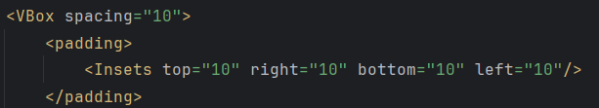
A Vbox is used to stack the form and buttons vertically with specified spacing.
HBox
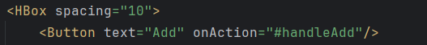
The buttons are created in HBox and it aligns them horizontally by creating a row of CRUD operations.

User Interface Controls
The application uses several JavaFX controls like:
Table View
The TableView displays the list of appointments which contains all the specified columns and each column is linked with the Appointment model.
TextFields
TextFields are used to enter the PatientID and PatientName and these data can be use later to create and update appointment.
DatePicker
The DatePicker allows users to select the appointment date.
ChoiceBox
ChoiceBox are used to provide predefined options in Doctor, Appointment Time and Condition.
Buttons
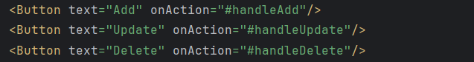
Buttons perform the CRUD operations, and it calls controller method when clicked.
MenuBar
MenuBar contains the menu which is used to Add, Update and Delete Appointment. Eacah of the menu items triggers the same methods used for by the buttons.

Event Handling and Listeners
The event handlers used in the application are:
Add Appointment
Creates a new Appointment object and adds it to the list.
Update Appointment
Updates the selected appointment with new values from the form.

Delete Appointment
Removes the selected appointment from the table.
Exit Application
Closes the application.
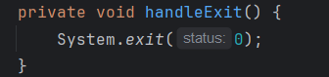
SelectionListener
There is a selectionListener for the TableView used in this application. When the user selects a row, the form fields automatically populate with the selected appointment data.

ObservableList and TableView Data
To store the appointments, there is ObservableList implementation in the controller file which will automatically updates the TableView whenever appointments are added or removed.
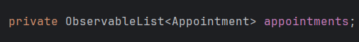
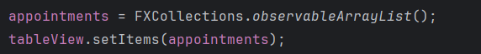

Validation
The application includes an input validation system implemented in:
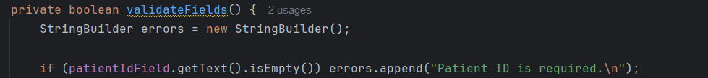
This will check whether the field is empty or not, if empty then will throw an error like:
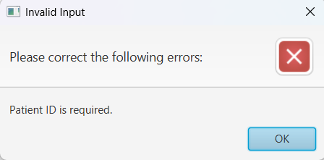

Challenges
The challenges I faced throughout the assignment were:
- Unable to Update the TableView
Initially, the TableView did not update the new appointment whenever tried to be added as I was using a normal list instead of the ObservableList. Then I used the ObservableList which solved the issue and it allows the JavaFX to observe the changes in the data.
- Connecting to FXML to Controller
Another issue occurred when the controller was not properly connected to the FXML file that caused runtime errors. To solve this problem, I added the fx:controller inside the FXML file which specifies the controller location inside the file, so that the layout controls can access the defined methods and operations without occurring any error.
- Finding Difficulty in Property Classes
At first, regular Java variables were used in the model class. However, TableView requires JavaFX Property classes to support binding. After replacing variables with StringProperty and ObjectProperty, the table displayed the data correctly.

Conclusion
The Health Appointment Manager application successfully demonstrates the use of JavaFX to build a complete GUI using the MVC architecture. The program includes a well-organized layout, interactive controls, menu functionality, and a table-based display of appointment records.
The application allows users to easily manage appointment data using CRUD operations. The use of ObservableList, event handlers, listeners, and input validation ensures that the interface remains responsive and user-friendly.
Overall, this project provided valuable experience in building JavaFX applications, working with FXML and Scene Builder, and implementing the MVC design pattern.

